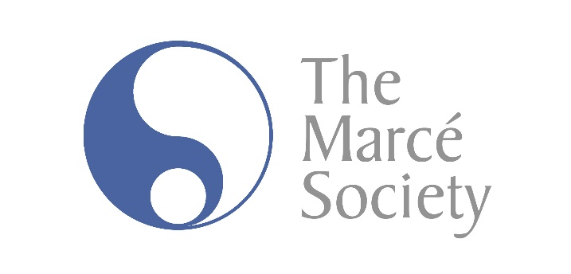

Thank you for purchasing the Marcé Society Resource Pack, please utilize the links provided below to the user’s guide and videos.

Please click on Users' Guide to read Resource Pack instructions.

Video Links: Puerperal Psychosis
Depression
Self Harm

Contributors

Copyright © 2013 Swansea University and the Marcé Society.
Intellectual property rights reserved by the authors.
The contents may be used freely by the purchaser for educational purposes or non-commercial uses as long as the source is acknowledged and the contents are used ‘as is’ and not edited or altered in any way without the written permission of the copyright holders.

